Software Requirements Specification
for
Cloud Based remote clinic management system
Prepared by Areesha Shaikh (1712138),
Kajal lohana(1712145)
SZABIST, Hyderabad
14/11/2020
Table of Contents
Table of Contents ii
Revision History ii
1. Introduction 1
1.1 Purpose 1
1.2 Document Conventions 1
1.3 Intended Audience and Reading Suggestions 1
1.4 Product Scope 1
1.5 References 1
2. Overall Description 2
2.1 Product Perspective 2
2.2 Product Functions 2
2.3 User Classes and Characteristics 2
2.4 Operating Environment 2
2.5 Design and Implementation Constraints 2
2.6 User Documentation 2
2.7 Assumptions and Dependencies 3
3. External Interface Requirements 3
3.1 User Interfaces 3
3.2 Hardware Interfaces 3
3.3 Software Interfaces 3
3.4 Communications Interfaces 3
4. System Features 4
4.1 System Feature 1 4
4.2 System Feature 2 (and so on) 4
5. Other Nonfunctional Requirements 4
5.1 Performance Requirements 4
5.2 Safety Requirements 5
5.3 Security Requirements 5
5.4 Software Quality Attributes 5
5.5 Business Rules 5
6. Other Requirements 5
Appendix A: Glossary 5
Appendix B: Analysis Models 5
Appendix C: To Be Determined List 6

Revision History
Name | Date | Reason For Changes | Version

Introduction
This section provides an overview of the derived software which is software requirement specification (SRS) for the subject cloud based remote clinic management system. As the purpose is present and it’s intended to audience outlined. The scope of project which is specified by document focuses on what the work will be done by clinic management system and which benefits it will provide.

Purpose
This document presents a detailed description of the cloud based remote clinic management system, its requirements, interfaces, objectives and how it will work. This system is designed for taking appointment remotely and the main aim is to have the records of the patient and centralized it for all the clinics. From this document the developers and customers, user simply can say stakeholders can be benefited.

Document Conventions
In this document the IEEE SRS template format is followed, as the convention of the document are covered in accordance with IEEE standard format for SRS template. For headings and sub headings the bold text is used.

Intended Audience and Reading Suggestions
In this document the intended audience are final year students of 2020 and there are also different types of readers that are respected jury, project supervisor, development team with tester.
This document contain a sequential overview of project (like overall description. Features of software, interfaces, requirements) so a reader if read the document can easily have the clear idea about project.

Product Scope
This system will help to manage and run the clinic system systematically. In this management system, the web app is provided through which the patient can easily take the appointment so no wastage of time and had benefits of having their records digitalized. By this system the patient can easily be managed by the staff and does not have crowd in a clinic and no time wastage of patients by waiting for their appointment number. Patient can see the timing of the doctors at a particular clinic. There is a patient screening system where patient can upload there reports url and doctors will have the opportunity to see the patient reports by inserting the patient search and see the records of the patient.
There will be a centralized database through which the clinics can see the patient records. The admin will be there for management and receptionist for accepting the appointment. In this app the clinics will be shown with their clinic types that which type of clinic is this.

References
<List any other documents or Web addresses to which this SRS refers. These may include user interface style guides, contracts, standards, system requirements specifications, use case documents, or a vision and scope document. Provide enough information so that the reader could access a copy of each reference, including title, author, version number, date, and source or location.>

Overall Description
This section present an overall description of the CMS. The characteristics of the system’s end-users are discussed along with identified system constraints and assumptions. In conclusion, it can be said that the distribution of the requirements are has been outlined.

Product Perspective
The remote clinic management system helps the clinic managers like receptionist or staff to manage the clinic easily, effectively and efficiently by computerizing the appointment of patient checkup, see the record system of patient easily and diagnose the disease. The system processes the appointments from patients and stores the resultant data while visited or not what is fees and all that. There will be a storage of patient report that patient can upload through the URL or by any other ways, so that the report will not be lost anywhere. The data will be centralized the clinics that will use the app will see the records (history) of the patient by their search name or id or CNIC. For example a patient was going in one clinic and this clinic is using this app and patient upload its reports by uploading URL or any other way that will be suitable, but know he/she visit to another clinic so that doctor can see the history reports of that patient from centralized database.
The whole management system is designed for a general computerized digital clinic system, so that every clinic use this system and can be facilitated by digitalized patient records, appointments any many more things.

Product Functions
The major functionalities are:

- Registration: the clinics, doctors, receptionist and patients had to registered first and get their username and passwords.
- Take appointment via app: patient can take appointment through web app by selecting clinic, doctor and timing, but it need a connection of internet.
- Clinic active status: the status will be shown whether the clinic is active or not.
- Confirm appointment: the receptionist will confirm appointment if doctor is free at that time and will later forward the list of appointments time to time to doctor. The receptionist will add fees when the patient will come for the visit.
- Centralized data: the patient data will be digitalized and kept centralized so the clinics that use this system can see the records of the patient.
- Upload reports: the patient can upload the test reports by uploading the URL or through any other source to the data for the record purpose.
- See patient records: if doctor want to see the records of the patient or want to see the last checkup and many more so that the doctor can fetch it from centralized data by inserting patient’s search source.
There are many more functions like patient appointment status where there will be that patient has visited or not but the major functions are given above.

User Classes and Characteristics
As the system will be used in the clinics so it has four active actors, which will be using and accessing the system:

- Administrator.
- Doctor.
- Receptionist.
- Patient.

Administrator:

Administrator is for the update and manage the clinics and patients profiles.

Doctor:
The doctor can see the list of patient in a queue, which was forwarded by receptionist and can access the centralized database for the records of the patient. The doctors should have the basic knowledge of computer for viewing list fetch data etc.

Receptionist:
The receptionist is responsible for scheduling the time of doctor, updating information that the patient has visited or not, accepting the appointment that the patient has requested and take the payment and store the payment information and other details in database.

Patient:
The patient will take appointment through app and select the clinic, timing or doctor and send request for the appointment to that clinic.

Operating Environment
This system will work inside the clinics for the appointment and for digitalizing the records of patient. Each clinic will have to register separately to this system and each patient had to separately register and take appointment by using web app. All we need is the web app, the internet connection and google chrome compatible browser needed for the users. The internet is must for the doctor also to connect to the centralized database.

Design and Implementation Constraints

- The internet connection is also constraint for the web application, as the application fetch the data from cloud database vice versa.
- The other constraint is that the receptionist has to manage the appointments day to day.
- The system must be delivered by deadline.
- The system must be user-friendly.

User Documentation
The system will provide the necessary required instruction to the clinics that how the system will work but there will be a document which will be intend to ensure the user’s feasibility. This document will be attached to the proposed system for the guidance of the necessary knowledge that how to operate with software. There will be each and every functionality about the features so without any trouble user know the system.

Assumptions and Dependencies
- It is assumed that, before installing the system and being tested the compatible computer should be available.
- It is assumed that the staff (receptionist) should be enough trained to take care of system.
- It is assumed that the internet connection will be as much that system works efficiently.
- It is also assumed that the receptionist add the correct information in the database.

External Interface Requirements

User Interfaces
The user interfaces between the users and the system will be easy or we can say user friendly that every type of user can use it easily. There will be a user manual/help option which will guide if there will be any problem that the user contains. As there will be a web app which will be interacted by patients, admin, doctor and receptionist for different purposes so every GUI of the system will be simple, will be familiar to the user and colors it contain will be relaxing. Input from the user will be via keyboard and mouse clicking.

Hardware Interfaces
As it is a web application so a browser is needed. It can run on a device this has a browser like a tablet, mobile or a desktop computer which can support browser.

Software Interfaces
As firstly it is mentioned that this system has one type of app that is web base. To store information MySQL is used for database and window operating system is used.

Communications Interfaces
It requires the internet protocol. MVC (model-view-controller) architecture is used in development and the HTTP (hypertext transfer protocol) communication standard is used for transfer data on web. The post and get request will be used which are methods of HTTP for the get and send data from the destination.

System Features
The main features which are included in this system are:
- Get patient an online appointment
- Digitalized patient data
- Getting the centralized data for all the clinics which use this system

Get patient an online appointment:
4.1.1 Description and Priority
The system provides three above features and all have the same priority as they all has the same level for which we are making this system. This feature will help patients to take appointment online without wasting time by going to clinics. The appoint will be send to the receptionist and confirmed by it then the patient will know the acceptance of the appointment by the patient appointment status that it is confirmed or not.

4.1.2 Stimulus/Response Sequences
Stimulus: patient will open the web application and perform actions to take appointment.
Response: the request of the appointment will be send to receptionist.
Stimulus: the receptionist accept the appointment by performing actions.
Response: the patient get the confirmation by patient appointment status.

4.1.3 Functional Requirements

REQ-1: Internet must be on (connected).

Digitalized patient data:

Description and Priority
As it is mentioned above that all three features are of same priority, while this feature will help the patient and doctor both. As if patient has the test reports while after some time it can be lost because of no use or the patient did not remember the place of test report so this feature help as the patient can put the test reports URL or by any other source that is suitable to that system and recommended, so it will be digitalized and can see the reports easily at any time. While it help doctors as the doctor can fetch the records of patient and see the previous history of patient.

Stimulus/Response Sequences
Stimulus: the patient will go to patient screening.
Response: it will give the screen having history of the patient record.
Stimulus: while doctor try to fetch record by performing patient search action.
Response: will get the previous history of the patient.

Getting the centralized data for all the clinics which use this system:
It is helpful for all the clinics that are involve with this system. As the data will be gathered at one place and patient upload their reports time to time the doctor of any clinic that is involve with this system can see the data of any patient by its search method.

Other Nonfunctional Requirements

Performance Requirements
The proposed system CMS is supposed to work effectively and efficiently in terms of its response time and capacity for every action.
The requirement can be specified by considering the following necessity:

Efficiency: To have less time consuming system, the clinics must have:
- Proper availability of high speed internet, as to achieve the efficiency for the real time action.

Effectively: The effectiveness of system is measured by its capacity of workload that is done in a particular time. So, in order to achieve the effectiveness of the system it must be capable of handling multiple users can interact with the system at the same time.

Safety Requirements
Safety plays a vital role in the development, as there are different data and actions.
As humans are error-susceptible, but there should be limitation of negative effects on common error for the users.
Example: if user want to delete data and putting action to delete data, but the user should realize by asking by confirming there intent or have the option to cancel.

Security Requirements
As MVC (model-view-controller) architecture is a web development framework and no any core language is used so this framework can control the security requirements and has the ability to control almost all the nonfunctional requirements of the system.

Software Quality Attributes
The software quality is maintained in a way that it should be user friendly that every user like patient take appointment easily without any difficulty and doctor receptionist or other can do their work easily. The software quality attributes are:
- Secured
- Fast speed
- Reliable
- Reusability of the data
- Compatibility
- Usability: the user can perform task safely, effectively.
- Correctness: The result of the function are correct and pure

Business Rules
The specific audience that is being targeted is the clinics. As to use this service firstly the clinics has to get monthly subscription.
Appendix A: Glossary
CMS: clinic management system.
Actor: user.
URL: uniform resources locator.

Appendix B: Analysis Models
- Activity diagram:

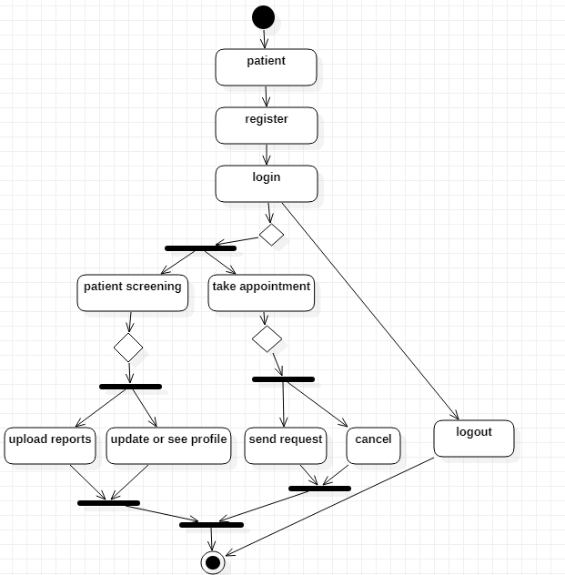
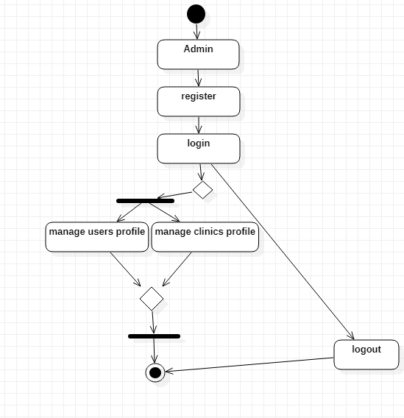
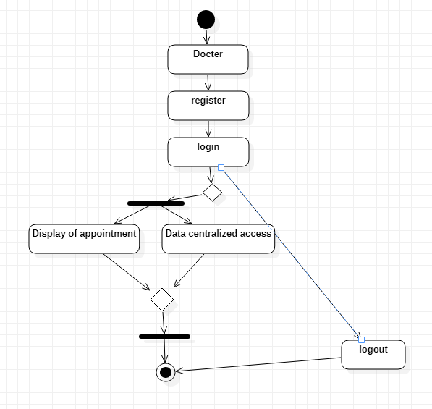

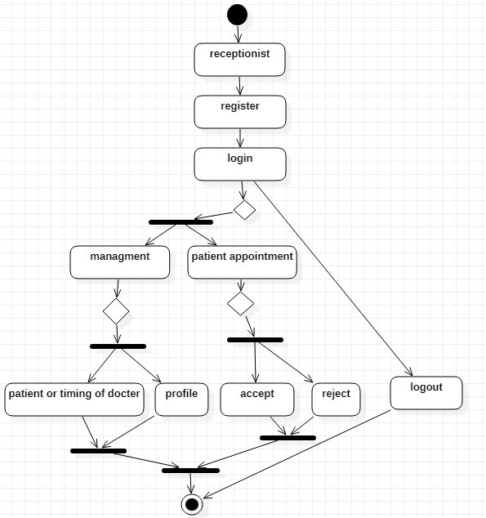

- Context free 0 level data flow diagram:

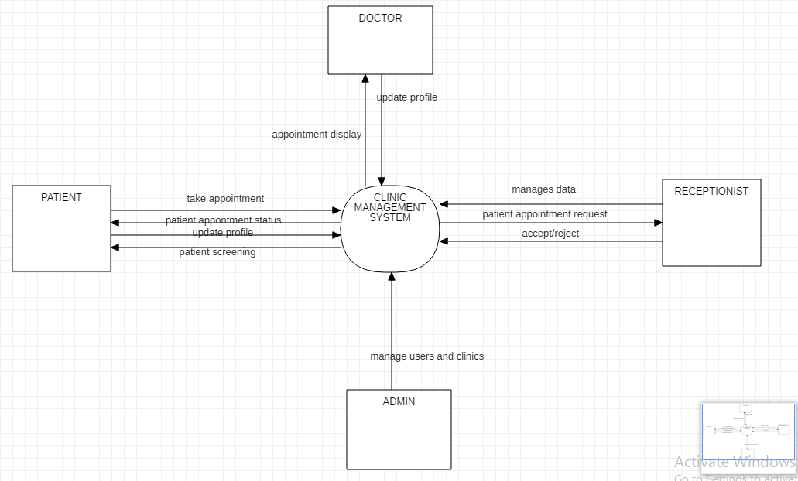

- Entity relationship diagram:
